|  |
| --- |
| Agoro |
| DayCent-CUTE 1.0 User Manual |
|  |
| Xiuying (Susan) Wang, Jaehak Jeong, Seonggyu Park |
| December 2022 |
|  |

|  |
| --- |
|  |

**Overview**

The DayCent model is a process-based ecosystem model that employs a daily time step and simulates plant processes (e.g., photosynthesis, phenology, dry matter allocation, senescence), soil water, soil temperature, soil organic matter dynamics for two plant litter and three soil organic matter pools, as well as mineral N transformations including N2, N2O, NOx, and CH4 emissions from soil (Del Grosso et al., 2006; Dozier et al., 2017; Ogle et al., 2010; Parton et al., 1998; Robertson et al., 2018; Stehfest et al., 2007). The model is widely used to simulate ecosystem responses to changes in climate and agricultural management practices in crop, grassland, forest and savanna ecosystems (Brilli et al., 2013; Cheng et al., 2014; Del Grosso et al., 2008, 2009; Hartman et al., 2009). One the other hand, applications of DayCent could be technically tedious since potentially many corresponding model parameters may need to be predefined or calibrated to properly represent the agro-ecosystem of interest. In considering this issue, the DayCent - Calibration and Uncertainty ToolsEt (DayCent-CUTE) was developed to facilitate the model’s sensitivity analysis (SA), automatic calibration, and uncertainty analysis routines with a user-friendly interface. The Python-based DayCent-CUTE was developed using the framework of APEXCUTE (Wang et al., 2014). The current version provides the flexibility to update more than 60 DayCent model parameters, with two global SA methods: a) extended Fourier amplitude sensitivity test (FAST) method (Saltelli et al., 1999) and b) Sobol (Sobol, 1993; Homma and Saltelli, 1996); and the Dynamically Dimensioned Search (DDS) algorithm (Tolson and Shoemaker, 2007) for DayCent model’s parameter optimization. It can also facilitate regional and national (multiple/numerous modeling sites) simulations and automatically assemble user selected model outputs.

The toolset can be used to complement users’ refinement of a DayCent model; however, users are responsible for conducting necessary checks for model input and initial runs before conducting SA and/or auto-calibration using DayCent-CUTE to make sure that the basic DayCent input and setup are correct.

1. **Program download**

A distributable DayCent-CUTE package can be accessed for academic research purposes by contacting Agoro Carbon Alliance directly (<https://agorocarbonalliance.com>).

DayCent model version: DD17CentEVI.exe and DD17list100.exe, which may be acquired from [NREL-DayCent: Daily Century Model (colostate.edu)](https://www.nrel.colostate.edu/projects/century/index.php)

1. **Program Installation**

Installation starts by executing the DayCent-CUTE_v1_winamd64_DD17Cent.exe. A local directory can be selected as the destination location where the program files will be copied. Windows Start menu can be customized and the start menu folder will contain a shortcut to run the program and a shortcut to uninstall the program. A user can choose to place a desktop icon for the program. Follow the in-screen instruction to complete the installation, which will copy files to the local computer (Fig. 1).

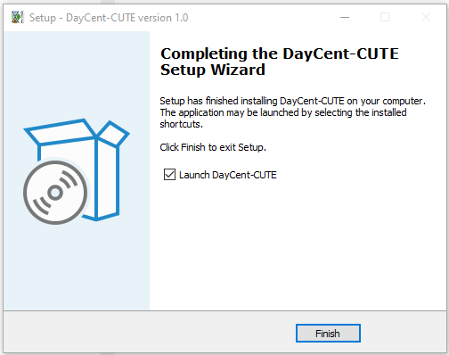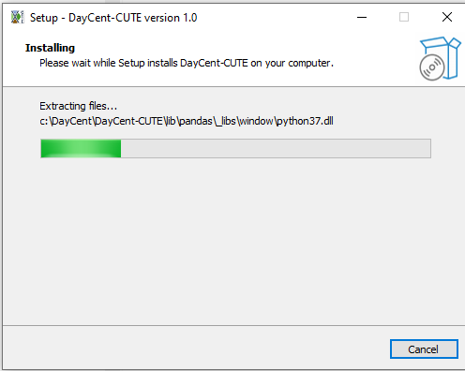

Figure 1. Installation of DayCent-CUTE

At this point, the installation is completed, and the user can start DayCent-CUTE by either from the Windows Start menu or by double clicking the desktop icon named as DayCent-CUTE 1.0.

1. **Example Dataset**

The installation package includes an example dataset with observed data formatted for DayCent-CUTE. The example dataset is a DayCent model for the site at Wooster, OH (Dick et al., 1997) with observed soil organic carbon (SOC). Measured data of corn and soybean grain yields, above-ground live biomass will soon be added. If the user installed the program at the default path, the program files are located at C:\DayCent\DayCent-CUTE folder. An example dataset included in the installation package can be found in the subfolder C:\DayCent\DayCent-CUTE\daycent_model (Fig. 2). Under the “daycent_model” folder, there are two subfolders: the folder “C:\DayCent\DayCent-CUTE \ daycent_model\Obs” contains examples of observation data and the folder “C:\DayCent\DayCent-CUTE\daycent_model\TxtInOut” contains the DayCent input dataset from the Wooster site. Detail description of the site is described by Dick et al. (1997).

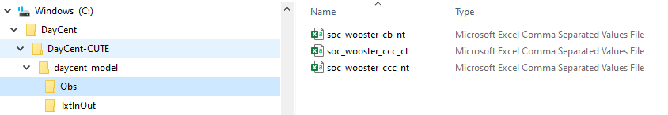

Figure 2. Example dataset

1. **Run DayCent-CUTE**

Users can create a folder and select it as the project folder. In this tutorial, the default dataset provided with the installation package will be used. All DayCent-CUTE files related to this project will be saved in the current project folder.

1. Start DayCent-CUTE by either from the Windows Start menu or by double clicking the desktop icon named as DayCent-CUTE 1.0.
2. Click Main tab -> New project (or **Browse** to open an existing project) -> Copy DayCent files

Next, provide the path where the DayCent model inputs are located. The user provided DayCent dataset will be copied to a subfolder “TxtInout” under the project folder as a backup. In response, the progress bar at the bottom of the main window will briefly move to 100% before being reset to 0%. You may click the third icon (“Save Project”, Fig. 3) to save the project path (not yet a fully populated DayCent-CUTE project).

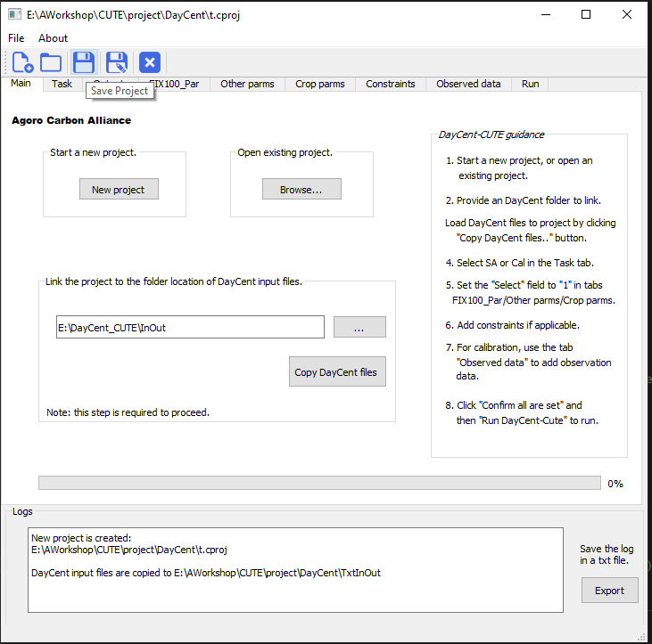

Figure 3. Main window for creating a new or opening an existing DayCent-CUTE project

**4.1 Sensitivity Analysis**

Task -> Sensitivity Analysis -> OK -> SA: FAST Method

Input options under Calibration Setting will become disabled because they are irrelevant to SA.

Outputs -> choose output to evaluate from the down-down list (Fig. 4)

Weight factor is not used for SA, leave it blank. You may add more output in column 2 to 4. Click the Save button.

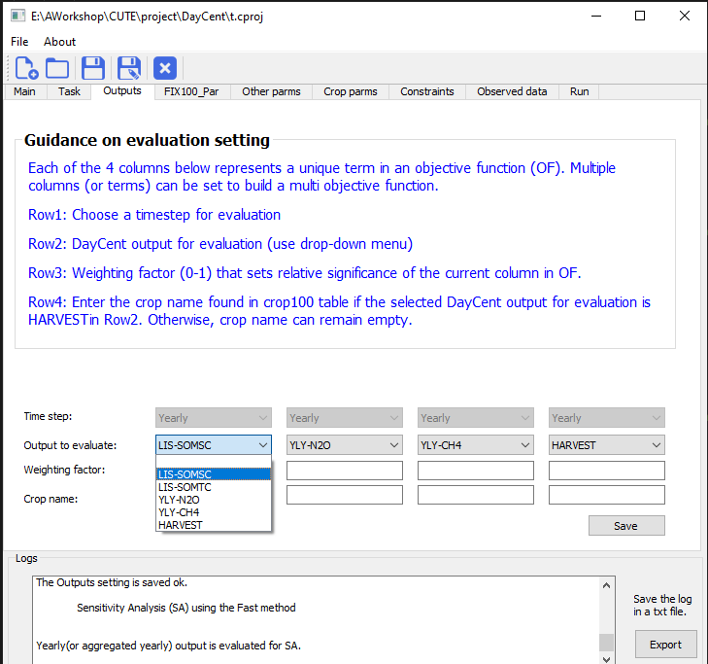

Figure 4. Outputs tab to choose DayCent ouputs for evaluation

Click open the **FIX100_Par** tab. Hover the mouse cursor over parameters on the Name column for parameter definition and description (Fig. 5). Reset the Select (On-Off) column value to 1 to select a parameter for evaluation. Select as many parameters as needed. Click Save button.

DayCent parameters (e.g. Table 1) that may be chosen to be included in SA and auto-calibration processes were based on previous DayCent studies (Gurung et al., 2020; Necpálová et al., 2015) and DayCent developers’ recommendations. The DayCent-CUTE 1.0 includes 48 model parameters (FIX100_Par tab) in the DayCent FIX.100 input file, 5 parameters in sitepar.in, 7 parameters in <site>.100 file, and 4 crop parameters in crop.100. Users can select all the relevant for the SA and calibration components. A SA is usually conducted first, and then influential parameters can be selected to be included for calibration.

Go through **Other parms** and **Crop parms** tabs (parameters in <site>.100 and crop.100 files have not yet been coded for updating; the current design is for regional and/or national studies) to select more parameters. Click the Save button on each tab to save the parameter selection. In the **Run** tab group, click the “Confirm all are set” button and then “Run DayCent-CUTE” button will become enabled. Click it to start the SA. DayCent-CUTE shows the progress bar and prints out “Run completed!!!” after the completion of SA runs.

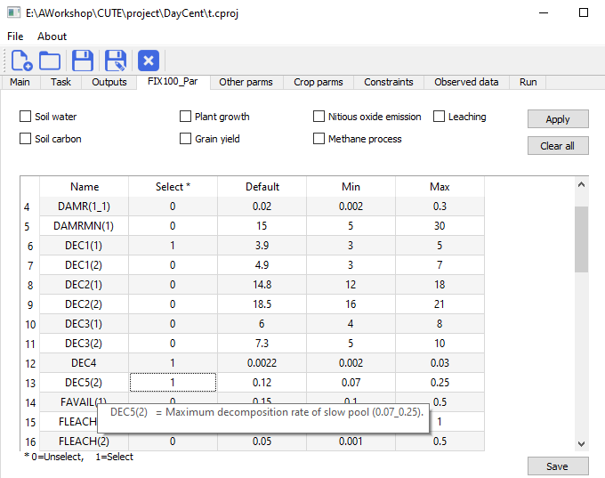

Figure 5. FIX.100 Parameters tab to choose parameters for SA or auto-calibration

**Table 1. Choice of DayCent parameters available in DayCent-CUTE 1.0.**

|  |  |  |  |  |  |
| --- | --- | --- | --- | --- | --- |
| Model parameter | Description | Initial value | Lower bound | Upper bound | File |
| ANEREF(1) | Ratio of rain/potential evapotranspiration below which there is no negative impact of soil anaerobic conditions on decomposition | 1.5 | 1 | 2 | FIX.100 |
| ANEREF(2) | Ratio of rain/potential evapotranspiration above which there is maximum negative impact of soil anaerobic conditions on decomposition | 3 | 2.8 | 5 |
| ANEREF(3) | Minimum value of the impact of soil anaerobic conditions on decomposition; functions as a multiplier for the maximum decomposition rate. | 1 | 0.2 | 1.1 |
| DAMR(1,1) | Fraction of surface N absorbed by residue | 0.02 | 0.002 | 0.3 |
| DAMRMN(1) | Minimum C/N ratio allowed in residue after direct absorption | 15 | 5 | 30 |
| DEC1(1) | Maximum decomposition rate of surface structural litter, strucc(1) | 3.9 | 3 | 5 |
| DEC1(2) | Maximum decomposition rate of soil structural litter, strucc(2) | 4.9 | 3 | 7 |
| DEC2(1) | Maximum decomposition rate of surface metabolic litter, metabc(1) | 14.8 | 12 | 18 |
| DEC2(2) | Maximum decomposition rate of soil metabolic litter, metabc(2) | 18.5 | 16 | 21 |
| DEC3(1) | Maximum decomposition rate of surface active organic matter, som1c(1) | 6 | 4 | 8 |
| DEC3(2) | Maximum decomposition rate of soil active organic matter, som1c(2) | 7.3 | 5 | 10 |
| DEC4 | Maximum decomposition rate of soil passive organic matter, som3c | 0.0022 | 0.002 | 0.03 |
| DEC5(2) | Maximum decomposition rate of soil slow organic matter; som2c(2) | 0.12 | 0.07 | 0.25 |
| FAVAIL(1) | Fraction of N available per day to plants | 0.15 | 0.1 | 0.5 |
| FLEACH(1) | Intercept value for a normal day to compute the fraction of mineral N, P, and S which will leach to the next layer when there is a saturated water flow; normal leaching is a function of sand content | 0.5 | 0.001 | 1 |
| FLEACH(2) | Slope value for a normal day to compute the fraction of mineral N, P, and S which will leach to the next layer when there is a saturated water flow; normal leaching is a function of sand content. | 0.05 | 0.001 | 0.5 |
| FLEACH(3) | Leaching fraction multiplier for N to compute the fraction of mineral N which leaches to the next layer when there is a saturated water flow; normal leaching is a function of sand content. | 1 | 0.2 | 2 |
| FWLOSS(1) | Scaling factor for interception and evaporation of precipitation by live and standing dead biomass | 1 | 0.2 | 2 |
| FWLOSS(2) | Scaling factor for bare soil evaporation of precipitation | 1 | 0.2 | 2 |
| FWLOSS(3) | Scaling factor for transpiration water loss | 1 | 0.2 | 2 |
| FWLOSS(4) | Scaling factor for potential evapotranspiration | 0.75 | 0.2 | 2 |
| OMLECH(1) | Intercept for the effect of sand on leaching of organic compounds | 0.03 | 0.000001 | 1 |
| OMLECH(2) | Slope for the effect of sand on leaching of organic compounds | 0.12 | 0.02 | 0.8 |
| OMLECH(3) | Amount of water that needs to flow out of water layer 2 to produce leaching of organics. | 1.9 | 0.02 | 2 |
| P1CO2A(2) | intercept for sand controlling C loss as CO2 during decomposition from active pool | 0.17 | 0.1 | 0.25 |
| P1CO2B(2) | slope for sand controlling C loss as CO2 during decomposition from active pool | 0.68 | 0.55 | 0.74 |
| P2CO2(2) | fraction of C loss as CO2 during decomposition from slow pool | 0.55 | 0.5 | 0.8 |
| P3CO2 | fraction of C loss as CO2 during decomposition from passive pool | 0.55 | 0.5 | 0.9 |
| PABRES | Amount of residue which will give maximum direct absorption of N | 100 | 70 | 200 |
| PEFTXA | Intercept parameter for regression equation to compute the effect of soil texture on the microbe decomposition rate (the effect of texture when there is no sand in the soil). See eftext calculation in prelim.f. The factor eftext is used in somdec.f and affects the flow out of som1c(2). | 0.2 | 0.1 | 0.7 |
| PEFTXB | Slope parameter for regression equation to compute the effect of soil texture on microbe decomposition rate; the slope is multiplied by the sand content fraction. See eftext calculation in prelim.f. The factor eftext is used in somdec.f and affects the flow out of som1c(2). | 0.4 | 0.2 | 1.5 |
| PMCO2(2) | fraction of C loss as CO2 during decomposition from soil metabolic pool | 0.55 | 0.35 | 0.7 |
| PS1CO2(2) | controls the amount of C loss as CO2 when soil structural decomposes to slow pool | 0.55 | 0.4 | 0.8 |
| PS1S3(1) | intercept for clay effect on C transfer efficiency from active to passive pool during decomposition | 0.003 | 0.002 | 0.005 |
| PS1S3(2) | slope for clay effect on C transfer efficiency during decomposition from active to passive pool | 0.032 | 0.02 | 0.06 |
| PS2S3(1) | intercept for clay effect on C transfer efficiency from slow to passive pool during decomposition | 0.003 | 0.002 | 0.005 |
| PS2S3(2) | slope for clay effect on C transfer efficiency during decomposition from slow to passive pool | 0.009 | 0.006 | 0.013 |
| RCESTR(1) | C/N ratio for structural material, strucc(1) and strucc(2) | 100 | 50 | 300 |
| RIINT | Root impact intercept used by rtimp; used for calculating the impact of root biomass on nutrient availability | 0.5 | 0.2 | 0.7 |
| SNFXMX(1) | Symbiotic N fixation maximum for soybean g N/g C new growth | 0.04 | 0.00001 | 1 |
| TEFF(1) | Step size (distance from the maximum point to the minimum point), for determining the temperature | 15.4 | 5 | 20 |
| TEFF(2) |  | 11.75 | 2 | 20 |
| TEFF(3) | step size (distance from the maximum point to the minimum point) | 29.7 | 10 | 40 |
| TEFF(4) | slope of line at inflection point | 0.031 | 0.01 | 0.04 |
| VARAT11(1_1) | Maximum C/N ratio for material entering surface som1, som1c(1) | 15 | 12 | 17 |
| VARAT11(2_1) | Minimum C/N ratio for material entering surface som1, som1c(1) | 6 | 4 | 6 |
| VARAT12(1_1) | Maximum C/P ratio for material entering surface som1, som1c(1) | 14 | 11 | 17 |
| VARAT12(2_1) | Minimum C/P ratio for material entering surface som1, som1c(1) | 3 | 2 | 4 |
| dmp | Damping factor for calculating soil temperature by layer | 0.003 | 0.001 | 0.01 | Sitepar.in |
| dmpflux | Dampens strong fluxes of water between soil layers | 0.000008 | 0.000001 | 0.0001 |
| N2Oadjust_fc | maximum proportion of nitrified N lost as N2O @ field capacity | 0.025 | 0 | 1 |
| N2Oadjust_wp | minimum proportion of nitrified N lost as N2O @ wilting point | 0.02 | 0 | 1 |

**Sensitivity Analysis Output**

Five output files as listed below will be generated and more detail is provided in Fig. 6.

1. **AvgOut_FAST.csv** – average annual DayCent output (e.g., somsc) for each iteration
2. **fastIndices.csv/sobolIndices.csv** – saves sensitivity indices (total order and first order indices for each parameter)
3. **YldOut_Fast.csv/YldOut_sobol.csv** – average annual values and annual values of DayCent output for each iteration (begin from output staring year as indicated in .sch file)
4. **FAST_sample_list.txt/sobol_ sample_list.txt** – this file has sampled parameters for SA
5. **params.txt** – DayCent parameters selected for the SA

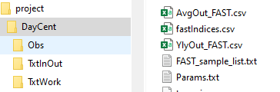

Figure 6. Output files after completing the sensitivity analysis.

* 1. **Calibration**

Repeat the procedures described in 4.1, but select “Calibration” in the “Task Option” instead of “Sensitivity Analysis”. Then click OK.

Configure calibration details in the Calibration Setting:

Check calibration period -> Number of iterations (It is recommended that this value be set between 500 and 5000) -> Performance indicator

Optionally, the user can also set a validation period and DayCent-CUTE output will include performance statistics for both evaluation periods. The calibration/validation period must NOT be out of DayCent simulation period as set in the .sch file.

Two options are available for “Calibration option” in the DDS Setting group:

1. **New calibration**: this option sets up a fresh new calibration and DayCent-CUTE deletes any existing calibration data and starts a new calibration.
2. **Continuing from previous run**: DayCent-CUTE collects calibration log in “DDS.out” and continue the previous calibration from where it stopped. This is optional but useful to complete a large calibration run that is stopped incompletely for a reason.

Initial parameter values are important in DDS calibration because DDS uses sampled parameters values and the model responses in previous runs to determine new parameters for the next iteration during a calibration. Two options are available as for “Initial condition for DDS calibration”

1. **User default values**: The first DayCent run will be made using the parameter values set in “Default” column in Parameters tabs.
2. **Random Sampling**: DayCent-CUTE will make five DayCent runs using randomly selected parameter values. The set of parameters that gives the best result among the five runs is selected as the first DayCent run.

Select Output to evaluate (the current version of DayCent-CUTE only evaluate annual or aggregated annual values, therefore, please set the Time step to Yearly) and parameters to calibrate in FIX100_Par and Other parms tabs. The Constraints tab is not activated in this version (place holder only).

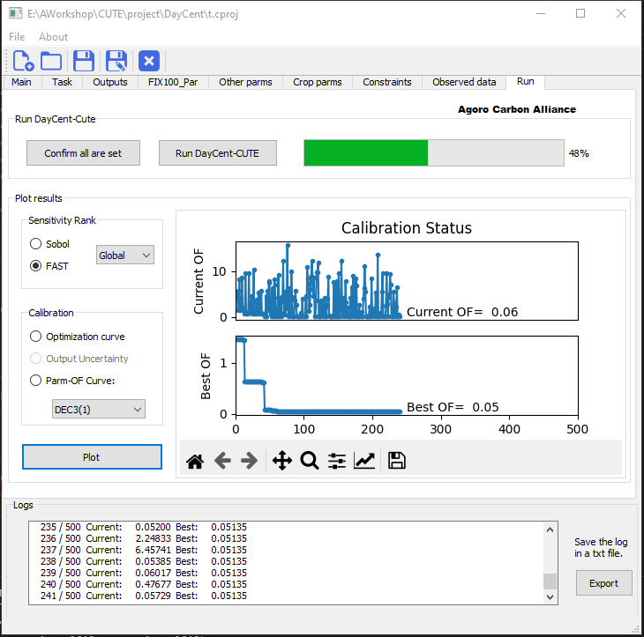

Figure 7. Screenshot of a DayCent-CUTE processing window during calibration

In the **Run** tab group, click the “Confirm all are set” button and then “Run DayCent-CUTE” button will become enabled after checking all inputs are set fine. Click it to start the calibration. DayCent-CUTE shows the progress bar (Fig. 7) and a message box will inform the calibration has completed.

**Calibration Output**

After the calibration is successfully completed, DayCent-CUTE generates three output files in the project folder.

1. The dds.out contains:

* Iteration run number (Run#);
* Corresponding parameter set values;
* Calculated objective function value (Test_OF) for this run; and
* The best objective function value (Best_OF) identified so far.

1. The DayCent.out saves:

* Iteration run number (Run#);
* Output variable (e.g., LIS-SOMSC);
* Objective function value for this run (Test_OF);
* The corresponding predicted output variable values for the years with observations, and
* The corresponding predicted output variable values (from starting saving year by last year).

1. The modPerf.out provides:

* Iteration run number (Run#);
* Model performance statistics for each calibration output in each DayCent iteration.
  1. **DayCent Single or Batch Run**

Click Main tab -> New project (or Browse to open an existing project) -> Copy DayCent files

Click Task tab -> DayCent Single or Batch Run -> OK

For this option, a user input file DayCentRUN.dat will be needed (Fig. 8). DayCent-CUTE will loop through this run file until it hits a blank line.

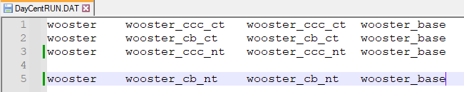

Figure 8. An example DayCentRUN.dat file for DayCent single or batch run

Check “Calibration period”, for this feature, if a user has observed values, the code will extract the paired predicted and observed values and calculate selected model performance (e.g., PBIAS for SOC). If some sites listed in the DayCentRUN.dat have no observed values, then CUTE will output the extracted (e.g., averaged SOC, if selected) values of these runs to SingleBatchRun.out. And sites with observed values will be output to SingleBatch_modPerf.out.

Click **OK** and select **Outputs** to evaluate (the current version of DayCent-CUTE only evaluate annual or aggregated annual values, therefore, please set the Time step to Yearly). This feature is for organizing multiple sites’ DayCent runs using user’s model input files; therefore, there is no need to select/update model parameters.

Click Run -> Confirm all are set -> Run DayCent-CUTE

After completion, DayCent-CUTE will print out “Finish DayCent simulation!”

**References**

Dick, W.A., Edwards, W.M., McCoy, E.L., 1997. Continuous application of no-tillage to Ohio soils: Changes in crop yields and organic matter-related soil properties. In: Paul, E.A., Paustian, K., Elliott, E.T., Cole, V. (Eds.), Soil Organic Matter in Temperate Agroecosystems. CRC Press, Inc. <https://doi.org/10.1201/9780367811693-12>.

Gurung, R.B., Stephen M. Ogle, F. Jay Breidt, Stephen A. Williams, William J. Parton. 2020. Bayesian calibration of the DayCent ecosystem model to simulate soil organic carbon dynamics and reduce model uncertainty. Geoderma 376 (2020): 114529.

Magdalena Necpálová, Robert P. Anex, Michael N. Fienen, Stephen J. Del Grosso, Michael J. Castellano, John E. Sawyer, Javed Iqbal, Jose L. Pantoja, and Daniel W. Barker. 2015. Understanding the Day Cent model: Calibration, sensitivity, and identifiability through inverse modeling. Environmental Modelling and Software. 66: 110-130. <https://doi.org/10.1016/j.envsoft.2014.12.011>.

Saltelli, A., S. Tarantola, and K. Chan. 1999. A quantitative, model−independent method for global sensitivity analysis of model output. *Technometrics* 41(1): 39−56.

Saltelli, A., S. Tarantola, and F. Campolongo. 2000a. Sensitivity analysis as an ingredient of modeling. *Statistical Science* 15(4): 377−395.

Schwieger, V. 2004. Variance−based sensitivity analysis for model evaluation in engineering surveys. In *Proc. INGEO 2004 and FIG Regional Central and Eastern European Conference on Engineering Surveying*, 1−10. Bratislava, Slovakia: SUT Bratislava; and Frederiksberg, Denmark: International Federation of Surveyors (FIG).

Sobol, I. M. 1993. Sensitivity estimates for nonlinear mathematical models. *Math. Modelling and Comp. Exp.* 1(4): 407−414.

Tolson, B. A., & Shoemaker, C. A. 2007. Dynamically dimensioned search algorithm for computationally efficient watershed model calibration. *Water Resources Res., 43*(1), W01413. <http://dx.doi.org/10.1029/2005WR004723>.

Wang, X., H. Yen, Q. Liu, and J. Liu. 2014. An auto-calibration tool for the Agricultural Policy Environmental eXtender (APEX) model. *Trans. ASABE* 57(4): 1087-1098. doi: 10.13031/trans.57.10601.